Diocese of St Andrews, Dunkeld and Dunblane – Diocesan Youth Committee
Introduction
Members of the Youth Committee undertook a survey of incumbents at the Diocesan Synod in March, primarily as a way of finding out which charges had any young people within their charge. A good response was received and the results were quite startling. Of 49 charges in the Diocese, a very small proportion have any young people under the age of 30. Those who do may only have one or two. Every incumbent asked that they be included in any information or resources which are available. The over-riding pattern has been mainly twofold:
- A number of young peoples activities have not restarted after Covid, due to the reduction in attendance at church or the lack of leaders willing to take on the commitment;
- Those who were attending have now moved on to higher education or employment and charges are experiencing the onset of an aging congregation
A number of committee members have kindly offered their reflections on how young people’s ministry has been affected in their charges and offers some suggestions on how to move forward for the immediate future. One member, who is involved at Provincial level, as part of the Provincial Youth Week has offered an insight into the leadership role during the week, and also how friendships made at the gathering continue into adult life and beyond.
Youth Work Reflections
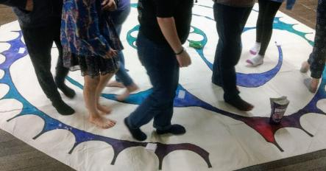
Youth work is never stagnant; it is always changing. Sometimes a church has young people and sometimes it doesn’t. Any group grows up and moves on. This constant flux has its challenges for those trying to lead activities in church for young people, but with a flexible attitude and an ability to listen to the needs of the young people, seeds can be planted that will bear fruit at whatever time is right.
The biggest challenge I have found in recent years is time. Young people can have very busy diaries with family, school, sporting and social commitments and there is often a struggle to fit in a regular church slot. Therefore, running irregular activities at times that suit without pressurising our young people enables them to feel part of church on their terms.
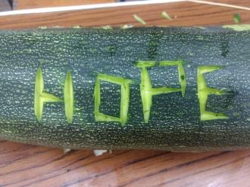
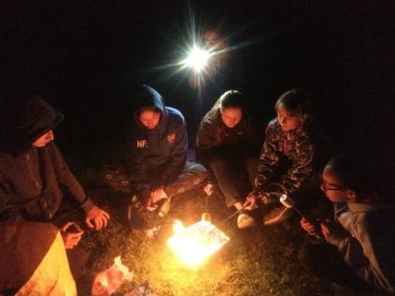
Pizza and film nights or trips out to local activities such as trampoline parks, ten pin bowling, rock climbing or paintballing have all helped young people connect and build positive relationships. Sitting down for a meal together to celebrate a season or mark an occasion can also be a simple way to connect. What has worked with one group doesn’t necessarily work for another, so be adaptable.
Listen, laugh and have a light touch.
HTKidz – refusing to shut up shop
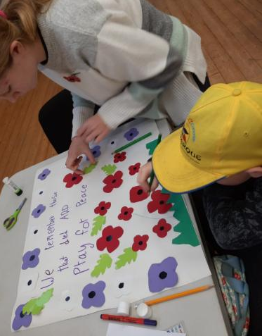
At Holy Trinity Stirling, post Covid, we can no longer sustain our primary age children’s group, HTKidz, on a weekly basis. We had a small but very enthusiastic group for a number of years, but during lockdown they left or moved on to high school. This is a source of sadness and has definitely changed the atmosphere in the morning service. But we have refused to shut up shop, or advertise that we no longer do children’s ministry. There are two or three smaller children who still come to church occasionally with their parents, and through a WhatsApp group we try to coordinate the occasional get together for games or crafts, making a special effort to do something at key times and seasons of the year. Sometimes there is just one child, but we’ll still meet. The emphasis is making ourselves available, and being in a position to offer something, however limited, to families who come, or may come in the future.
HTYF – creating a critical mass of teenagers
Typically, high school is when young people opt out of church. You need to offer them something different if their connection to church is to be maintained, something that involves hanging out with their friends and having a bit of fun. But most of our congregations don’t have enough teenagers to create a critical mass to make this work. In Holy Trinity, our answer over a number of years has been to get the one or two teenagers we have to ask their friends to come along. We meet on a Saturday evening, when most teenagers are at a loose end – the group can be any size from 5-10. We are blessed with a decent sized hall, and have bought, begged or borrowed various bits of games equipment. There is a great park a couple of minutes walk from the church for the summer months. The important thing is that this is not portrayed as a ‘church group’. Many of the kids have no or very limited experience of church, and they come along for the craic. There is a ‘God slot’ at the end of the night, where we explore some faith-related topic through activities, crafts, maybe a short film and discussion. But we are not aiming to ‘convert’ the kids or get them to come to the church, just to make them think a bit and, critically, to go away with a positive experience.
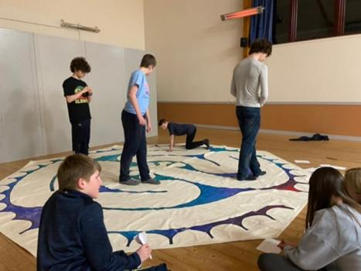

Banners and collages – releasing collaborative creativity
There is no shortage of resources out there for use with children and young people. The trick is finding material that works with the interests and dynamics of the group you have, and the leaders’ own creative abilities. Most stuff needs to be adapted in some way to suit your needs, and often we’ve found the need to create our own resources. A lot of what we’ve done over the years could we described as ‘messy church’ but we rarely use the official Messy Church books. One technique which we have repeatedly used is the creation of large scale banners or collages to explore themes, topics or seasons, or tell stories, Typically we will offer the kids a broad template within which the children can express their creativity. There is value in the collaboration, as well as the conversations with the children as they create the artwork. There is also usually an amazing finished product which can be brought in to church and displayed.

Celebrating Times and Seasons
Easter and Christmas are exciting times and congregations will typically want to create a distinctive and memorable focus for the children’s celebration/ reflection on the relevant narratives. For Christmas, we had held a Christingle services for years, but Covid gave us an opportunity to rethink and revert to something more traditional, but with a new twist. Our Rector had purchased a beautiful new crib set and we decided to revert to a short crib service on Christmas Eve with the story being told in a fresh contextual way as the crib figures were placed. The twist was having craft making sessions at intervals in the service where the children created items to enhance the crib scene – paper angels, silver stars, cloth strips to line the cradle etc. For Easter, our traditional activity is for the children to create an Easter garden in the church.

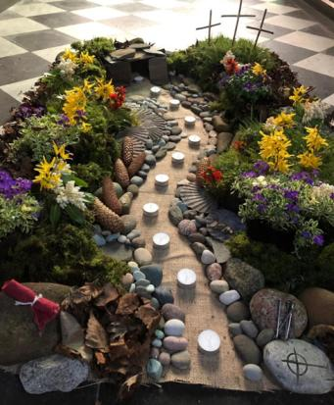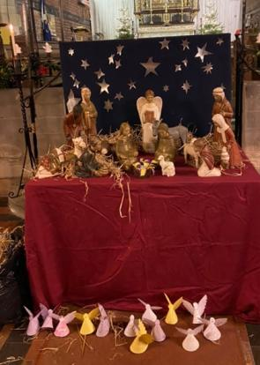

Fife Cluster Youth Fellowship
Fife Cluster YF began as a collaboration between Holy Trinity Dunfermline and St Peter’s Kirkcaldy and ran very successfully for several years until the end of 2022. Up to 12 or so youngsters from P7-S6 from both charges met weekly during termtime and enjoyed a wide range of activities. The delegates formed good friendships with each other, some of which have continued into young adult life and each delegate was encouraged and supported to attend the annual Provincial Youth Week.
During Covid, contact was maintained via a weekly Zoom meeting and it was surprising what a huge range of activities could be undertaken through social media. Art, scavenger hunts and baking were some of the activities on offer. Post Covid, meetings took place in person and a smaller number of delegates returned to meet either in Dunfermline or Kirkcaldy. However during 2021 a number of delegates moved on to higher education, and eventually it was felt that weekly meetings were unsustainable. Both Rectors met recently with Kirkcaldy Area Reachout Trust(a division of Scripture Union) where some useful suggestions were given on how to broaden youth work out into the community by inviting local youngsters to ad hoc events, for example, or making contact with other churches in the area.
Our SEC Superheroes
What do you get if you put together, a Software Engineer, a Hotel Duty Manager, a couple of Priests, an Airworthiness Manager, a Nurse, a Community Empowerment Officer, a Biological Safety Officer a Submarine Dismantling Project Senior Officer, an audio Engineering Student, and a housing officer?
No; this isn’t a start of a strange ‘what do you get’ joke, these is just some of the professions that make up some of our amazing Provincial Youth Leadership team who give up a week of their annual leave to support our young people in the Scottish Episcopal Church at the Provincial Youth Week (Yeek) held at Glenalmond College at the end of July beginning of August. Over a week, the Youth Leaders each volunteer for a 90-hour week of Youth Work, with days starting at 8am and often not finishing until 11pm at night. Some are even on duty for longer, as some roles over the week, requiring being ‘on call’ for 24 hours. Such roles include as being on night duty and the camps Designated Driver, to take anyone off to the hospital at any time of day or night, all working together to help grow the faith of teenagers in the Scottish Episcopal Church.
All of the leadership team, complete a deep dive application form to be considered as a leader at camp. This application form explores our own faith and relationship with God. How we continue our ministry away from the youth week, and how we all develop and sustain that throughout the year. As well as questions around dealing with conflict, working in a team, and being in a leadership role.
Being involved in Yeek, is an experience that is unique for the young people in our church. There aren’t many relationships that are formed as a teenager that then continue beyond the rights of passage that all young people go through. Relationships formed as teenagers at Yeek, continue as young people move to young adulthood and move away to Colleges or Universities with some also becoming leadership colleagues after a few years away from camp.
Several of the younger age group in the current and new leadership team for this year, I had as young people in my early years as a youth leader, and now they are planning and delivering the camp alongside me, and at the other side of the spectrum, some leaders were also my camp leaders! You can experience some of what happens and what our current young people say about Yeek by watching the video, made last year.
At the end of April, I had the joy of attending a second wedding since last summer, that was connected to the Provincial Youth Network. One was held in Inverness in September where two of the leadership team got married to each other, which was a wonderful occasion in itself, even though it was also around the time of great national sadness following the passing of HM The Queen. In April it was the turn of another leader who got married to her long-term fiancé in Glasgow. What was special about these two weddings was that some of the friends who were invited to them, were the same and the common connection was through the Provincial Youth Week. A common friendship, routed in fellowship by the SEC brings us all together from across the country as young people and delegates, to then sustain and deepen our friendships as young adult life and all the trials that come with it, to then also become colleagues working in a team to create a small part of God’s open and welcoming kingdom for a week in rural Perthshire.
Young Adults Group: Stirling/Bridge of Allan/Dunblane Area
On Tuesday 11th April, a new Young Adults Social group started up at St Saviours Bridge of Allan. This group is support by the three churches in the area. St Saviours Bridge of Allan, Holy Trinity Stirling and St Mary’s Dunblane. The group is for Young Adults from the age of 18 up to 40. This new initiative started as a pilot up to the end of the summer term, however due to the success it will continue after the summer holidays, as we expand our group to hopefully involve St Mary’s Dunblane young adults. The majority of the current group members are students at the University of Stirling, however we have also had members come from the local community who may have recently moved to the area, and due to home working aren’t able to socialise with many people their age in the community, or are already members of the charges and have been encouraged to come along and be part of the group.
The weekly meetings have been designed by the group and are facilities by James Gardner, Joan Lyon and Rebekah Sims, we have also had guest support from congregation members when one of the core team have been unable to attend a week and these run 7:30-9:30 in St Saviours Church Hall.
The weekly sessions end with Compline or a mediation depending on the activity of the week.
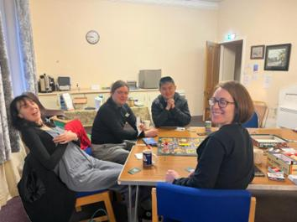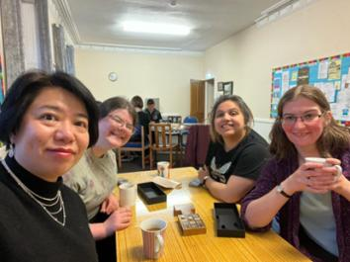
Board games night.
Conclusion
It is becoming apparent that a previous more formal arrangement for young people’s ministry is now not the norm, and that fewer but regular meetings may be the way forward. Perhaps, encouraging our young people to take up roles as servers or helping out with technology is a good way of engaging them with church to begin with; and for vestries to support any young people to attend the Provincial Youth Week, held in the summer. Or maybe charges could consider joining up with others in their area.
The Youth Committee hope that these reflections might be useful for your charge; please do not hesitate to contact any one of us for further help and support.

