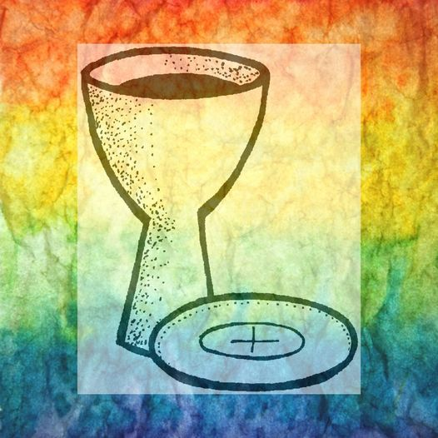

Perthshire Rainbow
Table
We are here!

7.30pm Thursday 17th February 2022

Thursday 17 March, Thursday 21 April all at

St Columba’s Perth Rd. Crieff. PH7 3EB.

Friday 3rd June Lunch Party at Hunter’s..

details to follow

We are an ecumenical Christian worship community which offers a warm welcome to people who are: LGBTQIA+ and their friends- all who seek an inclusive Church.

We aim to create a safe sacred space for you to explore your faith and what it means for you.
Whoever you are, wherever you come from,
you are welcome here.

https://strathearn-episcopal-churches.co.uk/
Contact Revd Gennie Evans rev.gen@btinternet.com

