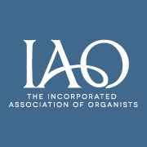
Tayside Organists’ Society

Incorporated Scottish

Association Federation
of Organists of Organists

Improvisation-
The Bones – The Flesh – The Personality

By Professor Norman Beedie

Thursday 17th October 2019 at 7.30pm
in Dundee Congregational Church,
Constitution Road,
DD1 1LL

All welcome

Tea/coffee served Admission free

