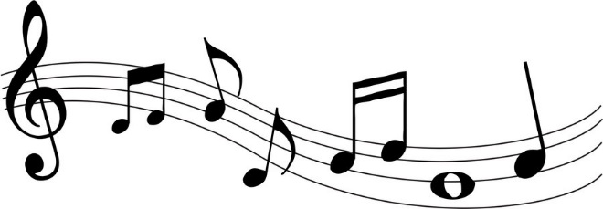

**Opus 8** 

presents

**“Autumn Tones”**

Sunday 17th November

3.00pm

St. James the Great, Dollar

FK14 7HF

**Tickets £5 each**

Light refreshments included

Tickets available from David Boggon, Members of Opus 8 & Brian Devlin’s

**Or on the Door**

In aid of St. James the Great funds. SCO02988