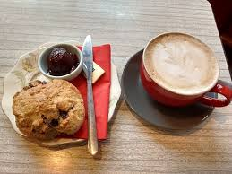

## AFTER A BUSY DAY COME AS YOU ARE

## TAKE A SHORT TIME OUT ON YOUR WAY HOME

## TO RELAX AND TO REFLECT

## TO ENJOY COFFEE, CAKES AND COMPANY

St. JOHN THE BAPTIST

Episcopal Church

Princes Street

Perth

PH2 8LJ

***CAFE***

***CHURCH***

**Wednesday 13thNovember**

**at 5.30pm**

**AL ARE WELCOME**