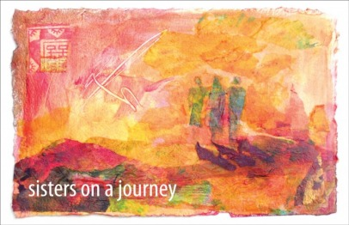

HerSpace is a group of about a dozen women who are willing to make a commitment to journey together from October 2019 to June 2020. This commitment will enable us to build relationships of trust, creating a safe space in which we can discover our deeper spiritual selves.
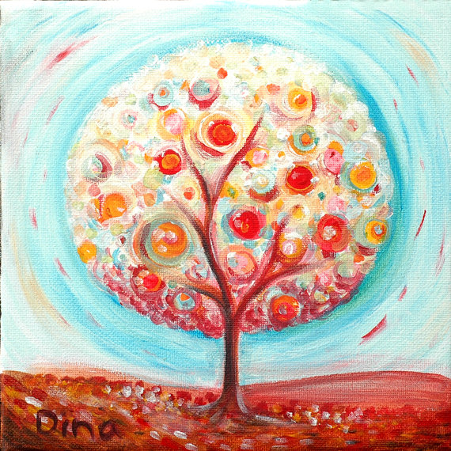
Our evenings together will be varied and fluid, sharing food, stories and activities that engage our whole selves. We plan on smiling, enjoying each other’s company, tapping in to a playful spirit, being gentle with ourselves, breathing deeply.

We hope you will leave this sacred space feeling nurtured and empowered, ready to step back into
your personal life, and the places you engage society and our world with renewed confidence and energy.

HerSpace is:

A space for women’s wisdom
women’s words
women’s witness

A space for soul food
food for thought
real food!

A space for creative expression
wellness practices
sacred story and ritual

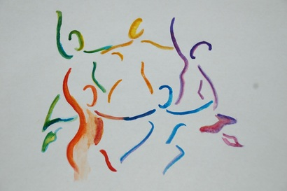

Facilitators

Valerie Allen: Valerie is a spiritual companion, retreat leader and minister with a particular interest in feminist spirituality. She is drawn to contemplative photography and Capacitar wellness practices.

Her spirit is nurtured in relationship with others, by mountains and wild places, through poetry, stillness, colour and music.

Marianne Anker-Petersen: Marianne is
co-director of the Bield. She has trained
as a counselor and spiritual companion.
She is committed to the listening ministry and to Capacitar body, mind and spirit practices.

Her spirit is nurtured by peoples’ stories and faith journeys, nature and the elements, art, beauty and poetry.

Gatherings take place monthly
on the following Thursday evenings from 18:00- 21:00 :

2019

3rd October
7th November
5th December

2020

16th January
6th February
19th March
16th April
21st May
25th June

Cost: £17 per evening (Includes dinner, refreshments and materials)

Please express your interest by signing up through Muriel :
info@bieldatblackruthven.org.uk
OR phone 01738 583238

We will confirm your place (or otherwise) by 19th September .
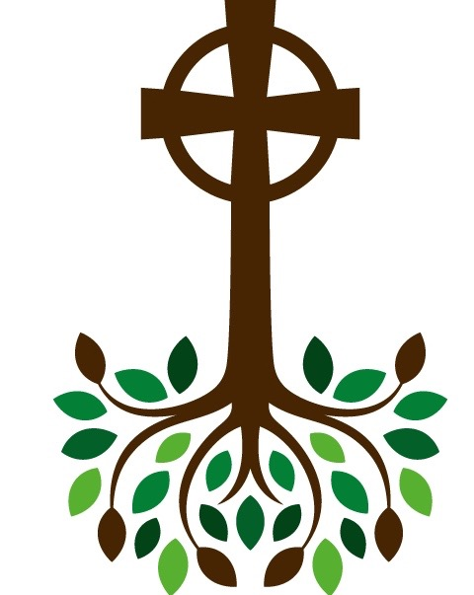

The Bield at Blackruthven, Tibbermore,
PERTH PH1 1PY

Scottish Charity SC 027462

Bield at Blackruthven

HerSpace

A monthly spirituality group for women

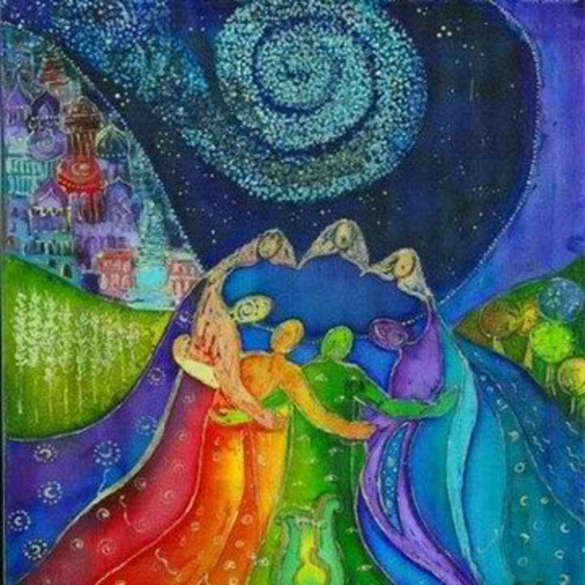

Begins:

Thursday 3rd October 2019
6.00-9.00 pm

