St Peter’s Episcopal Church, Kirkcaldy
SCO10443
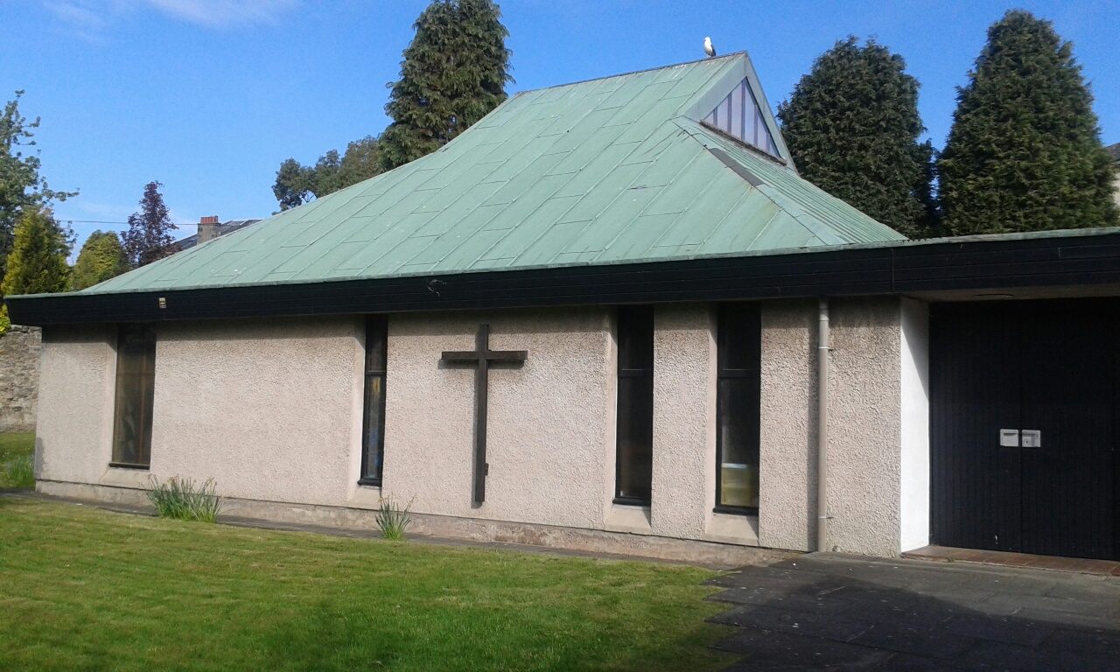

Choral Evensong
St Michael and All Angels
Sunday 29th September 2019 at 4.30pm
ABI Singers conducted by Josephine Quinney
Preacher Revd Dr Carrie Applegath,
Precentor St Ninian’s Cathedral, Perth
All Welcome

