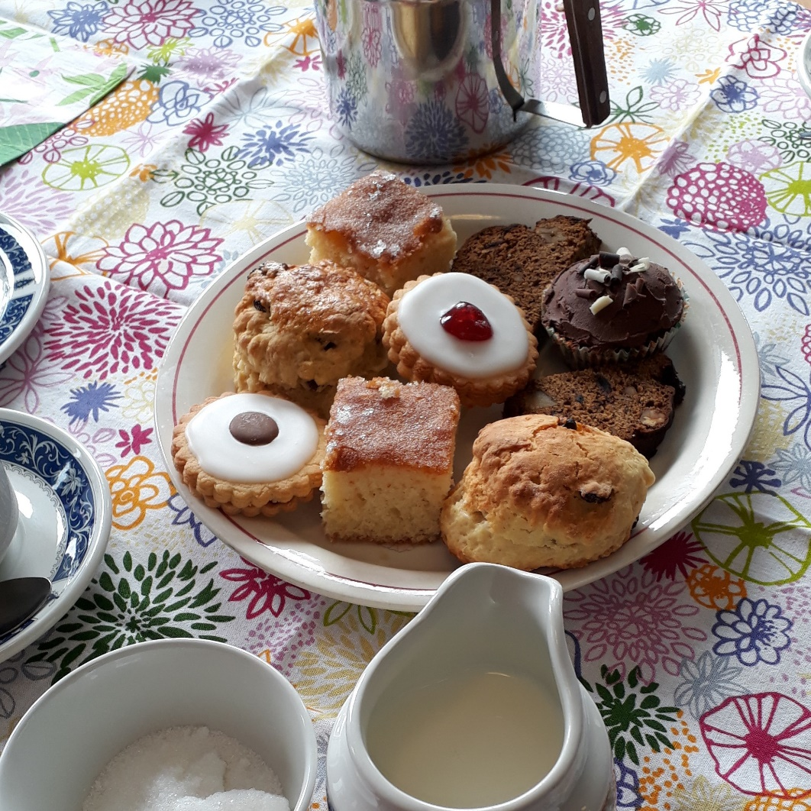  Cafe  Church  In the Threshold  Wednesday 11th September  at 5.30pm  
  AFTER A BUSY DAY COME AS YOU ARE
  ____
  TAKE A SHORT TIME OUT ON YOUR WAY HOME
  ____
  TO RELAX AND TO REFLECT
  ____
  TO ENJOY COFFEE, CAKES AND COMPANY
  ____
  ALL WELCOME
  St John the Baptist
  Episcopal Church
  Princes Street
  Perth
  PH2 8LJ

