Flute and Guitar Concert

Christian Schildmann, Flute
Ayman Jarjour, Guitar
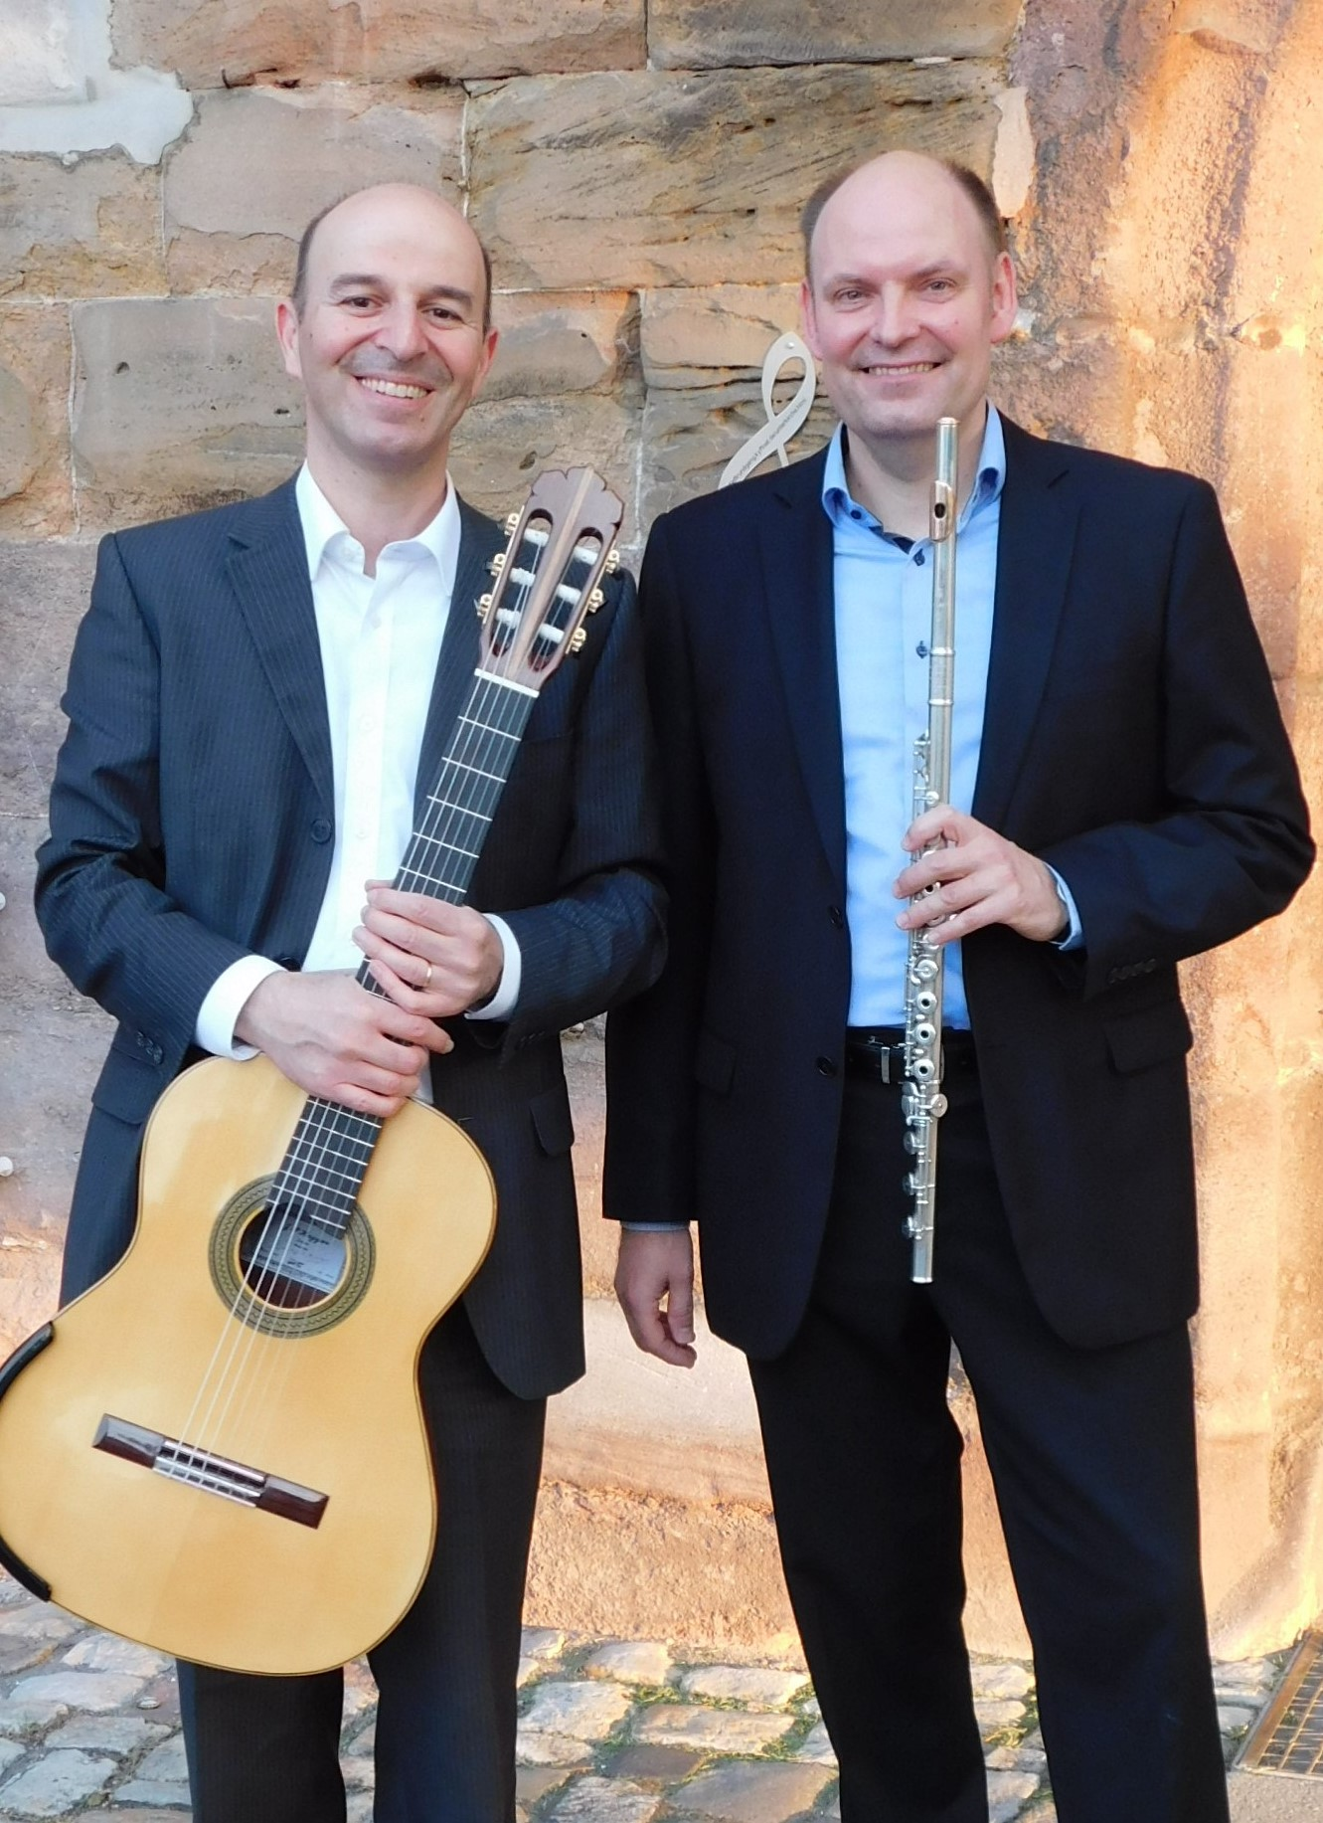

Thursday 25 July 2019 at 7:30pm
St John’s Episcopal Church, Princes St, Perth PH2 7LJ
Tickets £10 at the door

