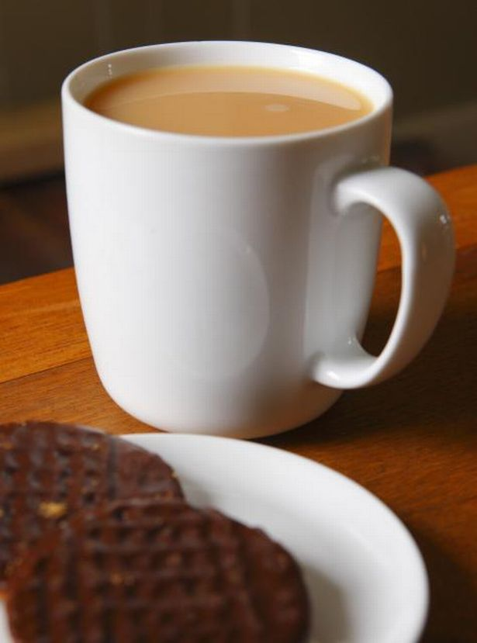

Cafe

Church

Church

Church

After a busy day take a short time out to relax and reflect, enjoy tea and cakes, have a chat and listen to what is happening in our community and further afield.
Wednesday 14th August at 5.30pm
at St. John the Baptist, Princes St. Perth
ALL WELCOME

