[**Benita & Ray**](http://mikedelaitre.co.uk/)

**Nostalgic Moments from the 1940’s**

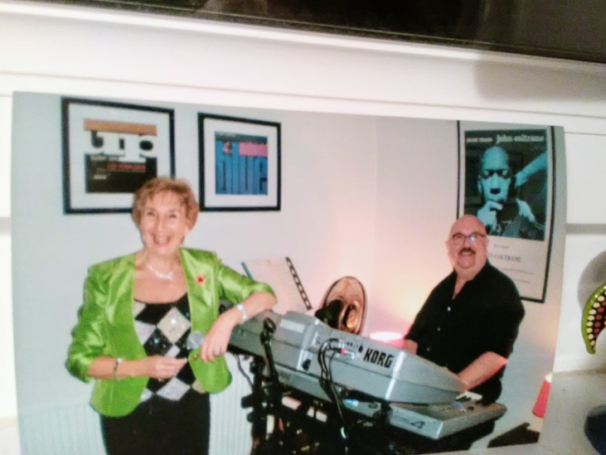

Come and be entertained with music from the 1940’s, Benita on vocals & Ray on keyboard.

**St. Finnian’s Church, Lochgelly**

**Friday 14th June 2019**

**7pm**

**To reserve tickets please contact Ross on 07947321687 or at** rossstirling81@hotmail.co.uk - **Failing that, tickets will be available on the door.**

**£5.00 entry including refreshments**

**BYOB**