QUIET GARDEN AT GLENEAGLES
www.quietgarden.org

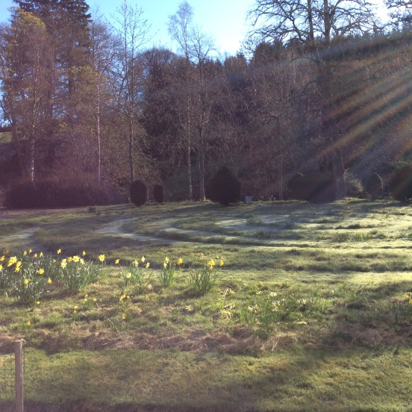

Tuesday May 14th, Tuesday June I8th
and Tuesday July 23rd 2019
1.45-5pm
to be led by
The Rev Charles Sherlock, Sarah Hill (Buddhist), The Rev Tracy Dowling

Warmth, tea and coffee are provided

Our aim is to provide an opportunity for stillness and reflection for visitors of any faith or none in the beautiful setting of Gleneagles, a chance to wander around this recently created wild garden or walk the grass maze and finish the afternoon with a short service in the private 16th century chapel.

‘It is essential to experience all the times and moods of one good place’ T. Merton

The first Quiet Garden was a dream of The Rev Philip Roderick that came true over 25 years ago. The Trust to which the Quiet Gardens are affiliated is in Buckinghamshire and has the vision of spreading a network of opportunities for stillness and reflection aided by the beauty of the garden.

Whatever our context, be it home or the workplace, let us all seek to find solitude as well as companionship, personal silence as well as good conversation…

‘Be still and know… ’ (Psalm 46:10)

ALL WELCOME - a suggested Donation of £3 to the Quiet Gardens Trust

Any enquiries to: Petronella Haldane, Gleneagles, Auchterarder, Perthshire PH3 1PJ
petronella@gleneagles.org 01764 682 388

