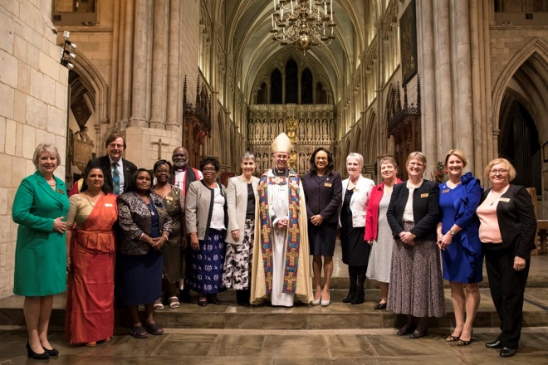
NEW WORLDWIDE PRESIDENT
February, 27th was a beautiful sunny day in London. As I walked down to Mary Sumner House I admired the beautiful spring flowers in St. James Park. It was such an auspicious day for Mothers Union.
I met with other Diocesan Presidents from Britain and Ireland and we enjoyed coffee and chat. Beverley Jullien introduced the day and how it was to progress. Then she introduced us to Sheran Harper, our new worldwide President. Sheran opened her talk by thanking us for all the work we do throughout our dioceses and asked that we pass her sincere thanks on to ALL our members. She told us about herself and her many varied roles in Mothers Union throughout her membership. We also heard about her husband and sons and the support they give her. She hopes to liaise with Provincial Presidents to visit all provinces for fellowship, to see projects and to meet members in the future.
We were then introduced to the new zonal trustees, one of whom is our own Paul Hindle. Their role, along with the Provincial presidents, is to oversee the work of the main trustee board.
The focus in the next Triennium is to be based around MULOA. Work in communities is to be continued and hopefully extended according to the MULOA outcomes in each diocese.
After a very informative morning we enjoyed lunch and then liased with the MSH staff on topics we required either help or more information on.
In the evening we made our way to Southwark Cathedral for the commissioning service. We were greeted at the cathedral by Calypso music from the Nostalgia Steel Band, to reflect Sheran’s Guyanese roots. The service was a traditional Choral Evensong. The Archbishop of Canterbury, the Right Revd. Justin Welby conducted a motivational sermon. He started by saying ‘There is only one Mothers Union!!! It is one of the Anglican Communion’s greatest gifts to the worldwide church. ‘He then preached on the adventure of Christian discipleship that leads us on as MU members. He spoke of the challenges ahead and the hope that Mothers Union brings to many around the world! Finally, as he always does, he asked us to ‘make ourselves known’ and tell our communities about our amazing work.
The commissioning of Sheran and the new Zonal Trustees took place. The Archbishop led a round of applause for all.
The steel band played again as the recessional party processed (in time with the music, especially the Archbishop!) down the aisle.
This was an extremely important occasion, not only for Sheran and the trustees but for all MU members as we welcome them to lead us in our work ahead. I was honoured to attend and represent our members in Scotland.
Jill Cameron, DP Glasgow and Galloway.

DEAR FRIENDS
Elizabeth reminded me that it was time for me to write my “piece” for the next edition of our e-news and I was wracking my brains as to what I could write as Lady Day has not happened yet, but by the time you read this it will have come and gone.
As I was sitting at my computer fingers poised to type an e-mail came into my inbox from the BRF (Bible reading Fellowship) with a reflection for Ash Wednesday. It was entitled “Behold, I stand and knock” based on the verses in Revelation 3 vv:20-22 and the picture by Homan Hunt called the “Light of the World” that we all I am sure know well. It posed the question “have we every paid any attention to our own front door?” How the lock works, what would happen if it broke, and the function of the door itself.
Without a lock anyone can come in or out at any time. A door doesn’t just keep people out it also lets them in and our heart is like this. Are our hearts shut and even locked or do we let Jesus and others in? Is it wide open or just ajar? Is it open all the time or only when we choose? We are reminded by the picture that Jesus always knocks. He doesn’t just barge in breaking the door down but waits to be asked in.
How to we respond when someone knocks on our door. Do we try to hide away and pretend we aren’t in; do we check to see who is there before we decide to open it or do we just fling the door open and say welcome, come in. Easter is coming are our hearts open ready to say welcome to the resurrected Jesus?
At our recent Trustees meeting we discussed how to be able to offer subscriptions to those who cannot afford to pay the whole amount and Branch leaders have been told the outcome of what we agreed. Anyone can donate money towards these and a small fund is being set up to hopefully be able to respond to such requests for help.
One of the trustees, Ann Rennie, who was elected at Council last year has had to stand down so we are really in need of at least one more person to join our small group. Is Jesus knocking on your door saying you could be that person? Please consider prayerfully if this might be the case.
But the sun is shining, the snowdrops are out and in many places the crocuses standing triumphant (the pheasants or deer eat them in my garden!) and surely spring is on the way.
Have a wonderful Easter and every blessing
Sarah
ASH WEDNESDAY WORDS 2019
- Fast from hurting words and say kind words.
- Fast from sadness and be filled with gratitude.
- Fats from anger and be filled with patience.
- Fast from pessimism and be filled with hope.
- Fast from worries and have trust in God.
- Fast from complaints and contemplate simplicity.
- Fast from pressures and be prayerful.
- Fast from bitterness and fill our hearts with joy.
- Fast from selfishness and be compassionate to others.
- Fast from grudges and be reconciled,
- Fast from words and be silent so we can hear.
As used by the Rev’d Tracy Dowling
LADY DAY
It was a lovely day as members gathered in St Mary’s Dunblane for the annual Lady Day service, made special this year as we welcomed our two Diocesan Bishops to commission the new officers.
We met Bishop Ian and Bishop Andrew over coffee and delicious baking provided by members, before moving into the Church where questions we put to the Bishops and they each told us of their personal journey to becoming Bishop and their hopes and plans for the future of their diocese and how the Mothers’ Union can help them.
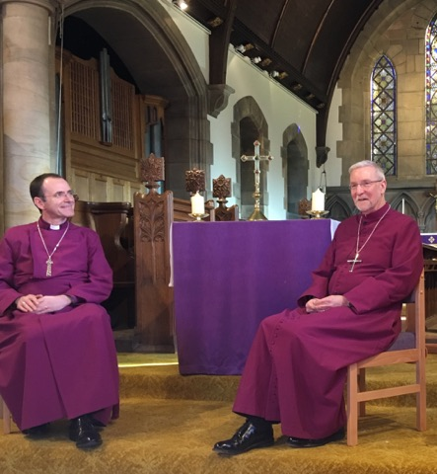
The Eucharist followed, with the branch banners processing in to lovely music being played by the organist.
Bishop Andrew gave the address and reminded us of a very domestic story of an ordinary girl called Mary who met an angel which changed everything. She accepted the challenge which the angel gave and God became one of us. We are challenged by that encounter and we have to trust God. The MU is changing to include everyone in our membership as a sign of that change. Lives are changed by the work of the M.U.
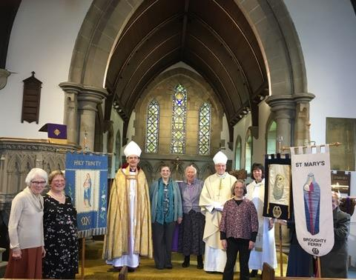
So what is the future of the Church and the MU. Can we find confidence to attract and accept new members? We have to trust in God as Mary did, As members of the MU we have a purpose to change things. Let us be that future.
Then came the commissioning of Sarah Gammell as our new Diocesan President by Bishop Ian, and Bishop Andrew then commissioned the new Trustee board, Jeanette Allan, Isabelle Pottinger, Liz Crichton, and Mary Kenyon, who sadly was unable to be with us.
The Eucharist continued and was very special. Photos taken and the banners paraded out.
We returned to the Committee rooms for our lunches with lots of chatter and renewing of friendships. And the sun continued to shine on what was a very special day.
Christ, the Son of God, born of Mary,
Fill us with your grace to trust your promises
And obey your will.
Sheila Redwood

WISE WORDS FROM OUR CHAPLAIN
Whilst the thought of having not one but two bishops in my church was quite daunting, I must say that I thoroughly enjoyed Lady Day! I particularly appreciated the opportunity to hear Bishops Ian and Andrew in conversation, responding to questions and comments put to them by those present. One thing Ian said struck a chord with me and took me back over twenty years to the time when I first came to St Mary’s. He spoke of the importance of belonging and how it can lead to believing.
I arrived in Dunblane in 1994 not knowing anybody. I was quickly made to feel at home at St Mary’s but, having grown up in the Methodist church where there is an emphasis on membership, I found the less formal approach of the Scottish Episcopal Church difficult. Since I had already been baptised and confirmed, our rector, Gian Tellini, was struggling to find a way to help me mark my decision to become an Anglican. Around this time, some of the younger mums at St Mary’s were beginning to be involved with the Mothers’ Union and I had been invited to join too. I remember the service very clearly: I remember being asked to stand up with the others to make my commitment and I remember the celebration afterwards in the hall. For me, who had left my roots in Wales, it meant so much to be able to say to others: ‘I belong to the Mother’s Union’.
And out of that sense of belonging came the confidence to become active in the life of the church. And through my involvement at St Mary’s came spiritual growth – a greater knowledge and a deeper understanding of God. Yes, belonging is important and it can indeed lead to believing.
Nerys

THE COST OF DISCIPLESHIP-worldwideNews
I noticed the other day two mention of our former Wave of Prayer dioceses in Nigeria. Firstly that the Bishop of Ahoada had been kidnapped and there were great fears for his safety, but then nothing further to say what had happened. I emailed the DP of Oxford whose link it is now and this is what she sent me back:
Bishop freed after kidnapping
The Bishop of Ahoada, Nigeria, the Rt Revd Clement Ekpeye, was kidnapped by gunmen from Bishop’s Court on Tuesday 18 December 2018. He was freed five days later on Saturday 23 December 2018 back to his family and church community where there was much rejoicing and thanksgiving to God. Please pray for the cessation of extreme violence in this diocese. Bishop Clement’s wife, Edna, is the Mothers’ Union Diocesan President. Please pray for Bishop Clement, his family and church community as they recover from this ordeal.
NB (Bishop Clement and his wife Edna are the same people whom we were in contact with so are our friends and known to us).
Maureen writes:-
I have written a letter to them both introducing myself and assuring them of our love and prayers. I am praying that it will reach them and they will be able to respond. We have our Wave of Prayer over Easter which will be a good time for all our members to remember our fellow MU members and their community in Ahoada in prayer.

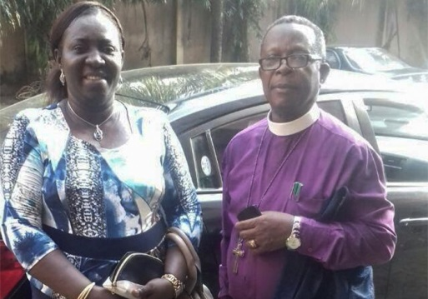
Then in a recent edition of the Church Times I saw that in Feb an Anglican priest the Rev Antony Idris Jata’u and his family in Sokoto had been kidnapped. Sadly the priest was later murdered, but eventually his family were released unharmed. In neither case were ransoms paid, as the paper says ..’Kidnapping is a huge problem in Nigeria.’
Please pray for both these diocese as well as for our current links and for the Church and the MU within them.
Elizabeth
HOLIDAYS!
If you are planning a holiday near Lake Como, you might be interested in the following article that was sent to me from the Chaplain there, the Rev’d Roger Williams.
The Church of the Ascension Cadenabbia Lake Como Italy

Should you be considering a trip to Italy and to the region of Lake Como you might like to consider calling in on the Church of the Ascension at Cadenabbia (Immediately opposite Bellagio) on Lake Como.
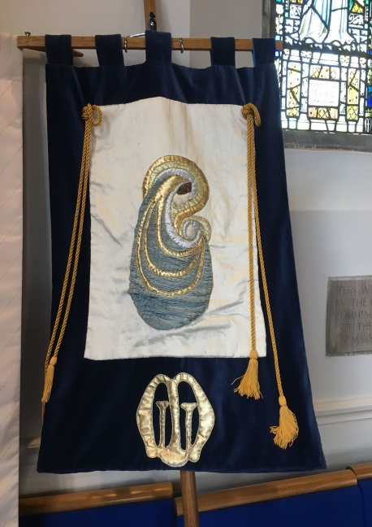
The Church is open daily and our regular Sunday Morning Service in English is at 10.30am to which you would be most welcome at this very inspiring and beautiful part of the world.
The Church is also available for Weddings, Renewal of Wedding Vows, Baptisms, Retreats and all the normal services of the Church.
The Church was built by residents and holiday makers back in the 1890's, it is one of the important land marks of Cadenabbia and should you be walking the Greenways Walk it is mentioned as a place to visit. This prominent church with a number of fine features
is immediately opposite the Passenger and Car Ferry in
Cadenabbia.
More information can be found on the website - www.churchonlakecomo.com or Facebook - Church of the Ascension.
Rev'd Roger Williams. Chaplain. Email - revrgwilliams@hotmail.com

DATES FOR THE DIARY

April 9th. Tuesday Prayers 11.30 -12.00 St Ninian’s
9th – 11th Provincial Retreat Kinnoull Perth
25th Daffodil Coffee Morning Gartlockbank
Coupar Angus
29th Training Day for all Trustees with staff from MSH at St John’s Perth 10.for 10.30am

August 2nd- 3rd Baby Changing Tent Perth Show
9th Mary Sumner Day An Exhibition of our MU banners is planned for the weekend at St Mary’s Dunblane to celebrate 130 years since MU started in Scotland, and its first branch was started at St Mary’s.
Book the day as it is going to be something special!

Don’t forget that our monthly Tuesday Prayer meets on the second Tuesday of each month (except August) in the Lady Chapel of our Cathedral at 11.30am for half an hour. It is a wonderful oasis of peace and calm, a real balm for the soul, and then usually we move on to a local café for a soup and sandwich lunch. Come and join us for refreshment for both body and soul.
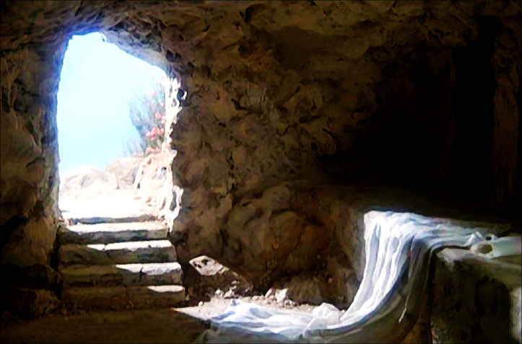

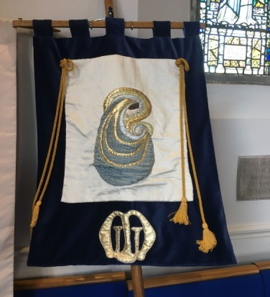
THE MOTHERS’ UNION WORKS THROUGH CHRISTIAN CONCERN FOR FAMILIES WORLDWIDE
CAMPAINING PRAYING AND ENABLING

A banner from Lady Day.
Come and see the skills of the banner makers at Dunblane on Mary Sumner Day Aug 9th.2019

God who through the resurrection of our Lord Jesus Christ has given us the victory. May we have joy and peace in our faith and strength to walk with him in his risen life.

A Happy and Blessed Easter to you all

