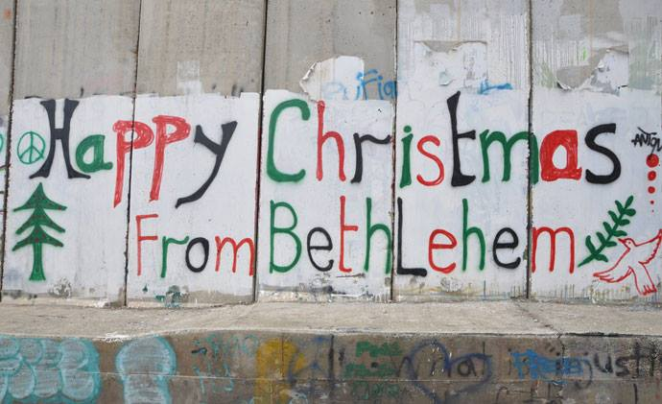

In November last year, the Global Partnerships Committee of the Scottish Episcopal Church received a timely application for a grant to pay for a Christmas party in Bethlehem. It was timely because it arrived just before our last meeting of the year, and we still had money to spend. It was also timely because Christmas was approaching and what better way could there be than to spend money on a Christmas Party for Palestinian children in the City of David, the City of the Nativity. The aim of the party was to bring the joyous spirit of Christmas to impoverished children and their grandparents.
So, what is the Global Partnerships Committee? It is a pendant committee of the Mission Board (or for those who are unfamiliar with Scottish Episcopalese, a sub-committee) and it has the remit of taking our mission beyond the UK worldwide. It has legacy funding of approximately £120,000 a year to spend on projects outside the UK, and has recently funded projects in Bangladesh, Brazil, Palestine and various parts of Africa. For a small committee, it has an extraordinary outreach on behalf of the Scottish Episcopal Church.
This is the story of one of those projects.
Wi’am, a Christian charity in Bethlehem, approached us to fund a party for 120 children, male and female, aged between 6-14 years, and for 50 elderly people. All of them came from the impoverished communities of Beit Jala and Beit Sahour in and around Bethlehem. The gifts chosen for the children were warm blankets, educational materials and chocolate, just for the fun of it.

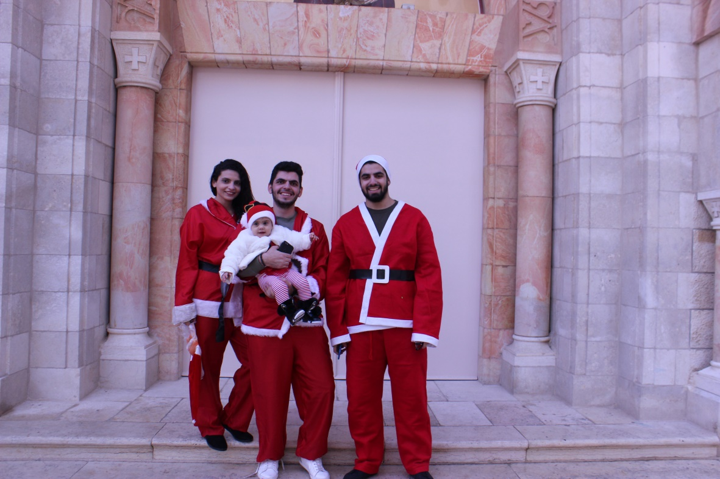
The party began with the Nativity story, the singing of Christmas Carols, including Away in a Manger and Silent Night.
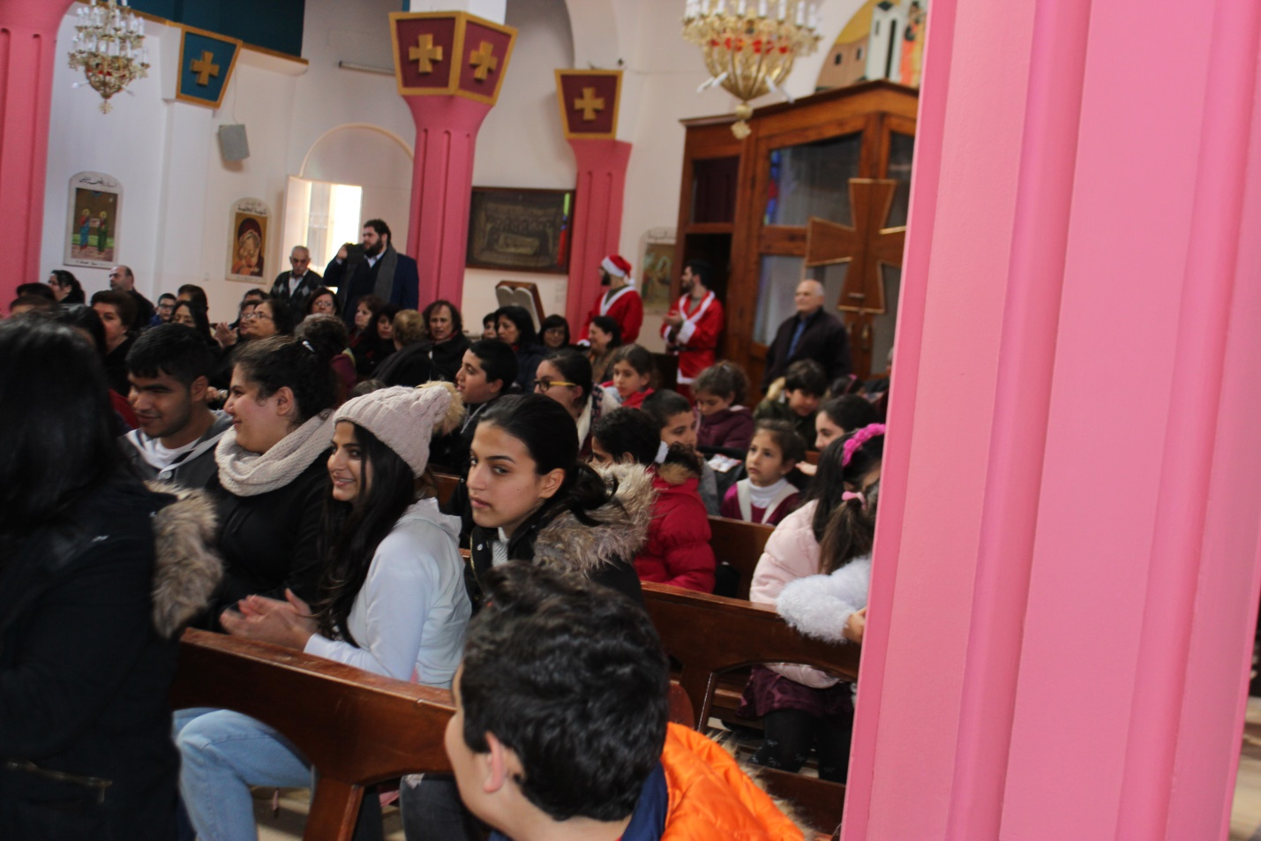
One of the musicians, playing a Qanun, a traditional stringed instrument, was blind. His playing thrilled the children.

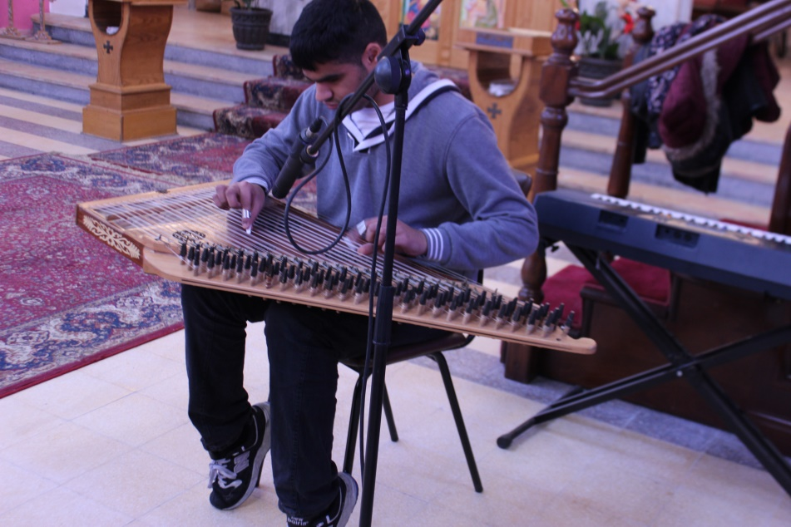
There was also a clown, magic and party games for the children
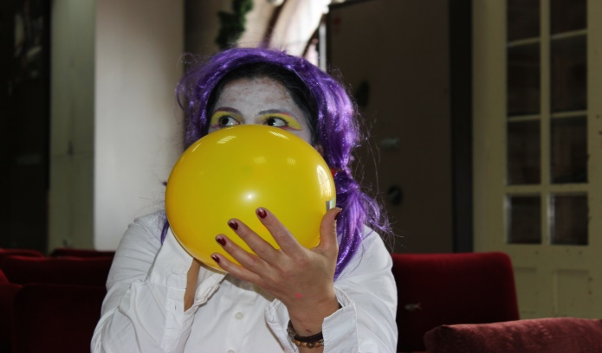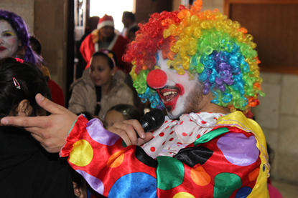
This is some of the feedback from the children at the event.
“It was a great event, it made me live the joy and happiness of Christmas… it helped me meet other folks and leave my isolation” (Mary, a senior citizen participant)
“I enjoyed the event greatly, it made me feel that children are still have room to smile and celebrate… Thanks to Wi’am center an much thanks to all the people who helped with this festival and gave me the chance to taste delicious chocolate and food.” 12 years old orphan girl
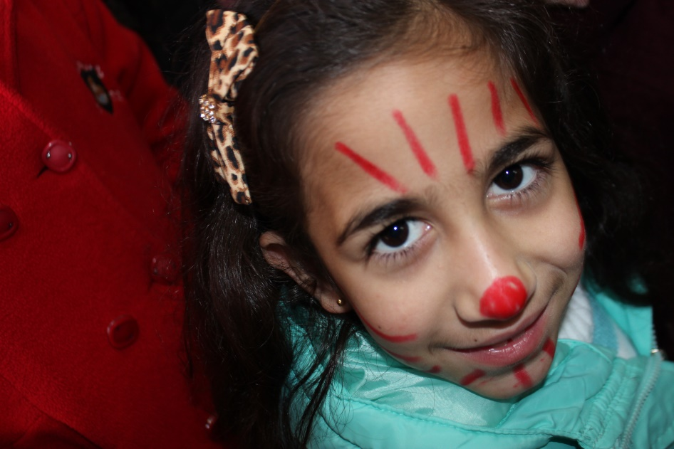

And the children loved the presents which were brought to them by Santa Claus himself, with the help of some elves.

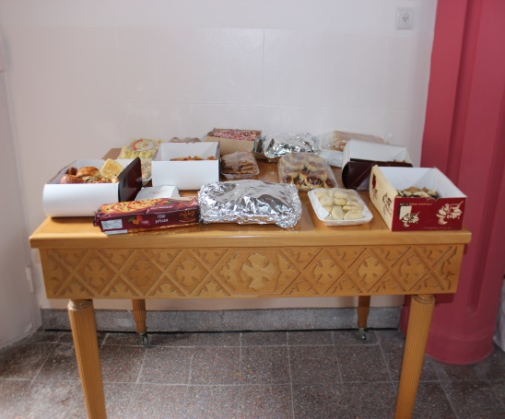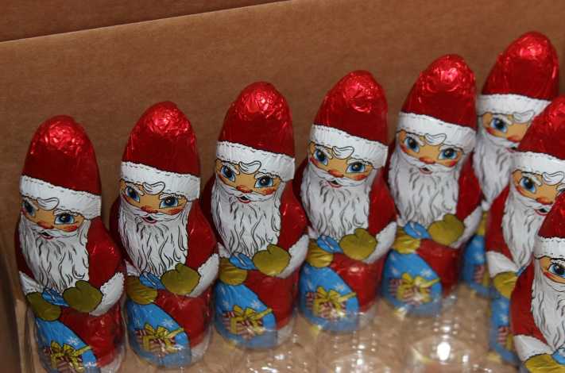

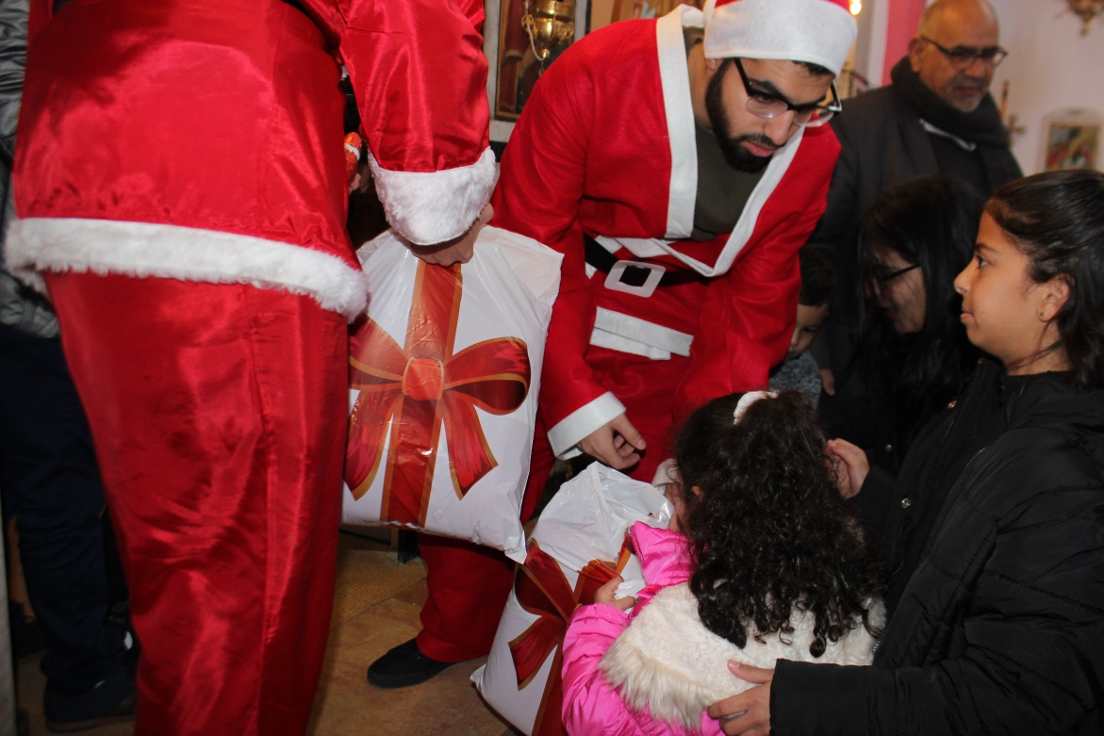
Before leaving the premises, the guests were invited to have some Christmas treat: light food, Christmas cookies, pastries, cake and beverages.
This is the message of thanks that we got from Wi’am
“On behalf of the Children, the senior and their families, Wi’am staff, express their utmost gratitude to the Scottish Episcopal Church in Edinburgh for their generous gift and tireless support for the event. They made this Christmas a joyful event for the lonely and impoverished seniors and the boys' and girls’. The senior’s and children’s faces light up with joy and wonder when they saw the mountain of presents, and realize how much they are loved and cared for by their communities and overseas friends. They can take home the love of others to them and what may well be the first NEW toy or blankets they have received in while.”

