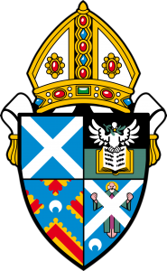
Diocese of St Andrews, Dunkeld and Dunblane

PHOTOGRAPHY
AS PRAYER

Visit a touring exhibition of 50 photos of people and places
taken by members of the diocese.

Launch events held at 2 p.m.
followed by refreshments

- St Peter’s Kirkcaldy, Sat. 8th September
- St Andrew’s St Andrews, Fri. 14th September
- St John’s Perth, Fri. 21st September
- Holy Trinity, Stirling, Sat. 29th September
- St Catharine’s Blairgowrie, Fri. 5th October
- Holy Trinity, Pitlochry, Fri. 12th October

