**Diocese of St Andrews Dunkeld and Dunblane and Church Army**

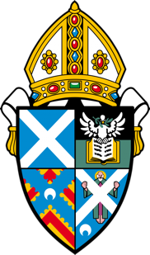 **St Luke’s Glenrothes and St Finnian’s Lochgelly**

Is God challenging you to come to Central Fife?

We seek an ordained Evangelist willing to join the Church Army Community, who is passionate about seeing people come to a living faith in Jesus and to grow, and empowering other people to do the same.

We seek a gifted leader who will sustain and guide our two congregations into a new era of Evangelism and Mission.

The successful candidate will concentrate efforts on those who do not attend church and grow fresh expressions of church across the area enabling the inherited congregations to be fully involved.

You will be assisted in this exciting ministry by a pioneer evangelist whom you will help recruit.

You will have experience in strategic planning for mission and enabling church growth, with a proven track record of sharing your personal faith and nurturing new disciples in order to establish and grow the Central Fife Centre of Mission that is a partnership between The Diocese of St Andrews, Dunkeld and Dunblane and Church Army. This person will be accountable directly to the Diocesan Bishop.

We are committed to moving forward with hope, and are faithfully expecting great things from God as we attempt great things for Him.

Closing date 24th August 2018

Interview dates will be notified.

For an application pack or an informal discussion contact:

Rev Canon Kerry Dixon CA

Email: kerry.dixon@churcharmy.org Tel: 07711410017