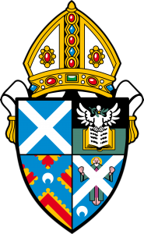
Diocese of St Andrews, Dunkeld and Dunblane

PHOTOGRAPHY AS PRAYER

‘Our People and Places in Photos’
Submission Form

Photographer’s Name

E-mail address

Phone/Mobile Number

Home Address

Church

Age (if under 18)

Would you like your photo(s) returned to you? YES/NO
(If so, please include a firm self-addressed, stamped envelope with your prints.)

You may submit up to 3 photographs. Your photograph(s) may be accompanied by a few of your own words or a short piece of prose, poetry or scripture you feel is relevant to it. Please enter words below:
Photo 1

Photo 2

Photo 3

If your photo(s) contain images of identifiable people, please download the Consent Form which is on the diocesan website and ask them to sign it. If they are under 16, there is a separate consent form for parents/carers to sign.

