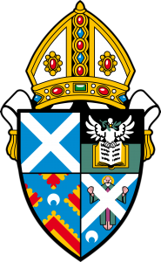
Diocese of St Andrews, Dunkeld and Dunblane

PHOTOGRAPHY
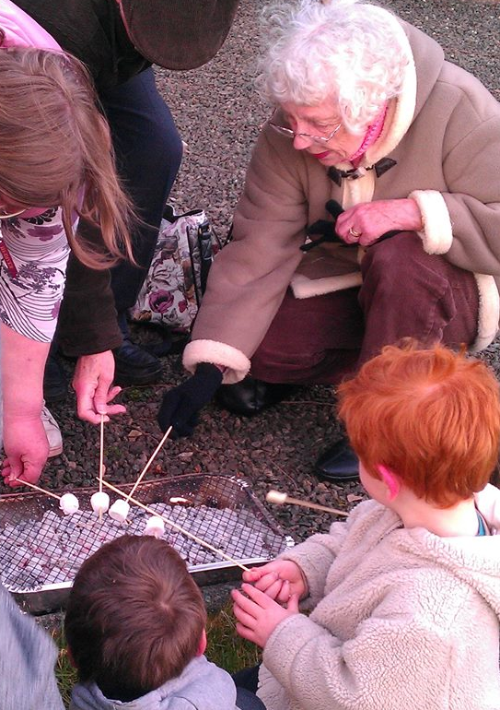
AS PRAYER
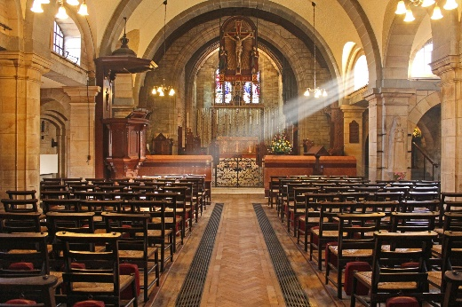
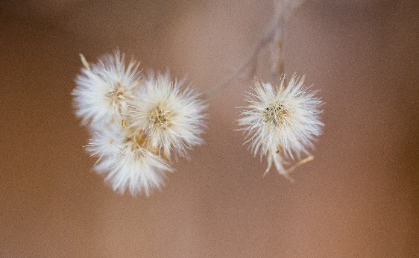

Our people and places in pictures
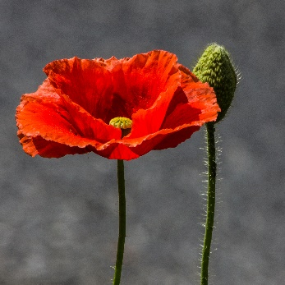
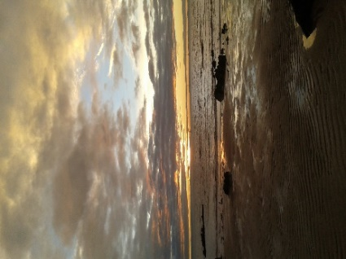

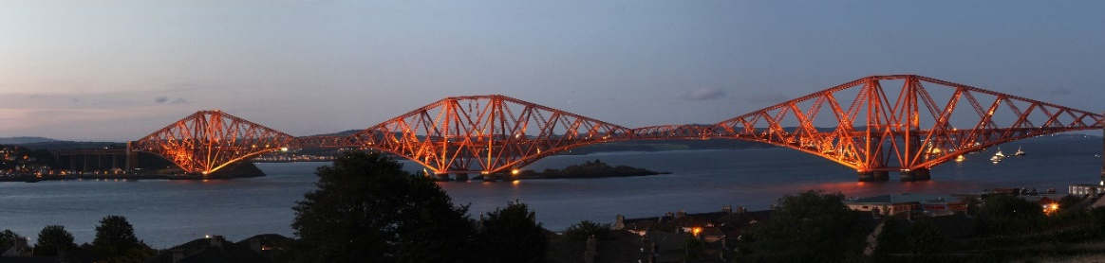
An invitation to contribute to a travelling exhibition and a chance to feature in a 2019 Diocesan Calendar

No expertise or special equipment needed. All ages welcome to get involved. Deadline 30th June. Please look out for a leaflet in your church,
visit www.standrews.anglican.org or the diocesan Facebook page. If you have any queries, please contact Ian Scott at: skobz@btopenworld.com
SOME THOUGHTS BY IAN SCOTT,
LAY READER AT ST MARGARET’S LEVEN

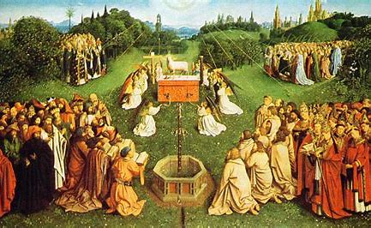
Imagery has been a part of religious life for centuries, from the earliest cave paintings and ancient carvings, eastern church iconography, western European altar pieces such as The Adoration of the Lamb by Van Eyck, to post renaissance art which often depicted stylised biblical scenes, and of course, stained glass windows. For many, these images were a great comfort and aid to their worship, providing a focus for their meditation and praise, a focus which allowed them to set aside the distractions of everyday life in the 21st century, a form of mindfulness if you wish.

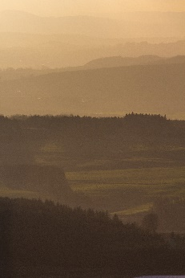
In Mark’s Gospel we read that Jesus said to Peter, ‘You do not have in mind the concerns of God, but merely human concerns’. Being mindful can help us put aside the clutter of human concerns for a time so we can meet with God. For me that comes with a walk on the beach or in the countryside, but more so when I take time to really see the beauty of creation around me, sometimes within a wide view of a stunning landscape, and at other times, deep down in the structure of a flower or small insect.
Ps 121:1 I lift up my eyes to the mountains- where does my help come from?

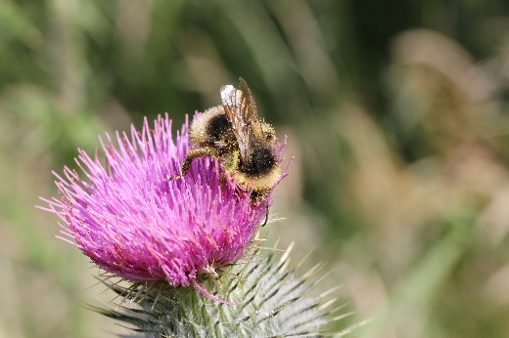

The time I take to set up and take a photograph is for me, a form of mindfulness. I try to disconnect from the clutter, and focus on the image that I am receiving. Receiving … yes that is how I see it. I don’t take photos, I am often given them, sometimes in the most unlikely places. Special equipment is not needed. Modern compact cameras and most smart phones can take very good photographs. The best camera or lens for a particular shot is actually the one you have with you at the time. Often walking mindfully without rushing helps us to see things we might otherwise miss. Stepping back and looking, but also closing in on a subject or viewing it from an unusual angle can help to produce an interesting image. Sometimes the image will speak for itself, at other times you may find that it points you to a particular piece of poetry, scripture or an inspiring quotation. Often this comes later as you view and meditate on the image learning to see meaning within it.
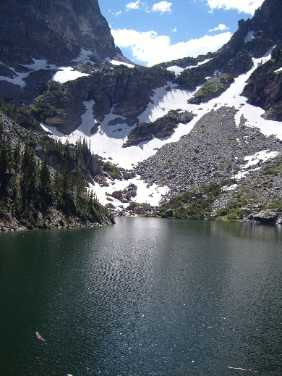
I would therefore like to encourage members of all churches to rise to this challenge and produce images for an exhibition which will travel around the Diocese later this year. Please take as many shots as you like. After all, that is what this project is all about. However, due to logistics we would ask that you restrict your submissions for the exhibition to a maximum of three images per person, and if you have a significant surplus then why not show them off in your own churches as well. Finally, let me finish with one of my images and some inspiring words by John Muir:

We are now in the mountains and they are in us, kindling enthusiasm, making every nerve quiver, filling every pore and cell of us. One learns that the world, though made, is yet being made; that this is still the morning of creation; that mountains long conceived are now being born, channels traced for coming rivers, basins hollowed for lakes.

PRACTICAL INFORMATION

What kind of photo? Any image from our Diocese which resonates with you and your faith. It can be of a church or other structure, people, plants, animals or landscapes. Anything really, that catches your imagination, using any camera (even phones these days can produce quite stunning quality).
How to submit the photo? 10” x 8” print, or if printing yourself, up to A4 size on photopaper. Send this to the Diocese Office at 28a Balhousie St., Perth, PH1 5HJ. (For return of your print(s) please include a sturdy stamped addressed envelope). Also an electronic copy of 1-3 MB to skobz@btopenworld.com
What information to send with it? A submission form is available to download from the Diocesan Website. Your photograph(s) may be accompanied with a few of your own words or a short piece of prose, poetry or scripture you feel is relevant to it. If your photo(s) contain images of identifiable people, please download the Consent Form which is on the diocesan website and ask them to sign it. If they are under 16, there is a separate form for parents/carers to sign.
What will happen next?
Photos will be displayed in an exhibition which will travel the diocese between September and November 2018. Entrants will be informed by e-mail of the locations and dates of events. Twelve of the images will be selected to be included in a diocesan calendar for 2019 which will be sold to raise funds for further Diocesan Photography and Prayer events.
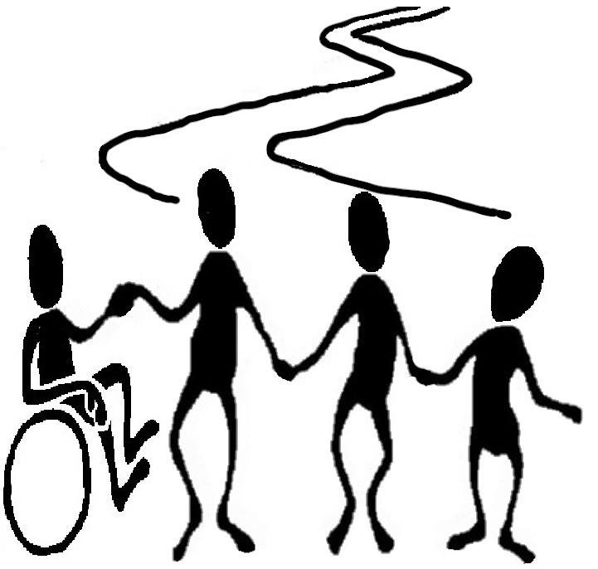

JOIN US AS WE CONTINUE OUR JOURNEY TOGETHER

