Labyrinths in the Diocese of St Andrews, Dunkeld and Dunblane: a guide

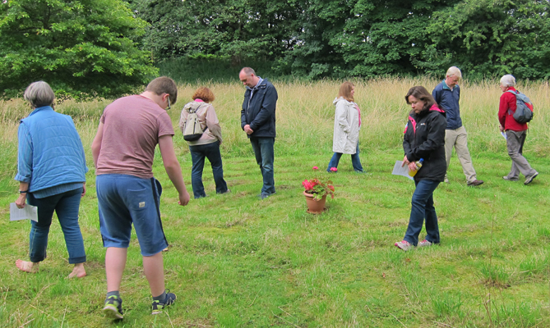
The Glebe Meadow
St Serf’s Church, Comrie
PH6 2JA
Accessible at any time.
Parking is behind the church. Follow signs to Comrie Golf Course. For a guide or hospitality: www.strathearnchurches.org.uk

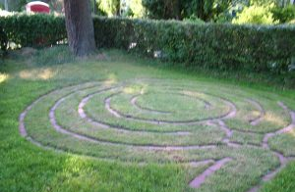
The Church Garden,
St James the Great, 12 Harviestoun Road, Dollar, Clackmannanshire FK14 7HF
A double labyrinth, accessible at any time. Leaflets inside the church. For a guide or hospitality:
www.stjamesthegreatdollar.org.uk/
educationresources/labyrinth/

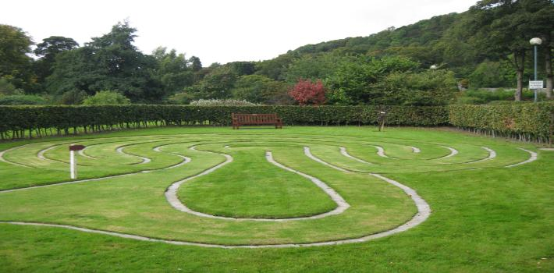
University of Stirling, on the north side of the campus, past Airthrey Castle and the golf academy.

Free access at any time. Contact St Saviour’s Church, Bridge of Allan for a guide: www.saint-saviour.org
The Bield at Blackruthven, Tibbermore, Perth, PH1 1PY www.bieldatblackruthven.org.uk
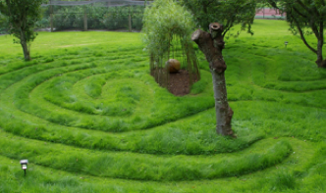
A traditional 7 circle grass labyrinth has been created in the orchard and a second contemporary labyrinth in the old tennis court suitable for wheel chair users and for walking with buggies.
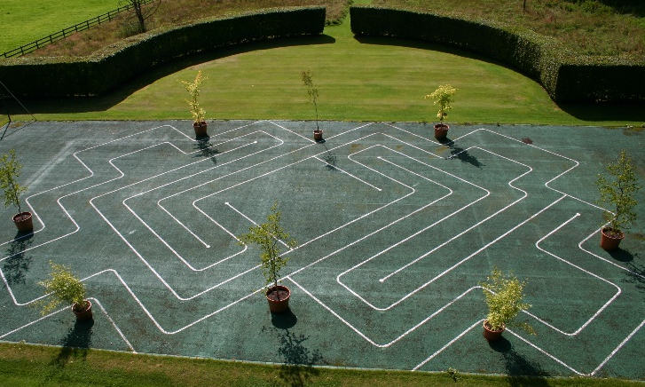
Open Tuesday to Friday and every alternate weekend. The labyrinth is regularly walked in summer time as part of evening prayer at 5 p.m. and all are welcome to enquire and join.

Free access but please contact info@bieldatblackruthven.org.uk or phone 01738 583238 beforehand.

Kinburn Park, Doubledykes Road, St Andrews KY16 9DP
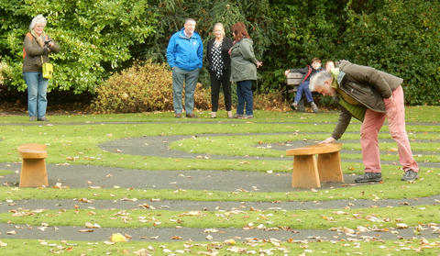
Free access at any time. Accessible to wheelchair users. Information leaflet in Tourist Office or Kinburn Park Museum.

Contact St Andrews Quaker Meeting for an introductory guide: www.quakerscotland.org/st-andrews

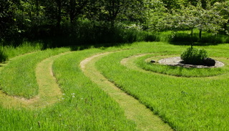
St John’s Labyrinth, St John’s Lodge by Bishop’s Bridge, Ceres KY15 5NF
The garden labyrinth is open on Thursday afternoons during the summer months or by appointment. Donations in aid of local charities. For group visits please contact Nicholas and Barbara Davey in advance: stjohnsgardenceres@gmail.com

Riverside Park, Leslie Road, Glenrothes, KY6 3EP, between the wildlife pond and the skate park.

Constructed by members of St Columba’s Church of Scotland. Free access at any time. For an introductory guide contact minister@st-columbas.com
JOIN US AS WE CONTINUE OUR JOURNEY TOGETHER

The St Andrews’ Diocese Labyrinth Group provides training for those interested in becoming Labyrinth Walking Guides and will also host Labyrinth Walking Events. We also have an indoor labyrinth which can be borrowed to be used in churches or church halls. For more information, please contact Rev Nerys Brown enabler@standrews.anglican.org
What is a labyrinth?
A labyrinth is a path of prayer laid out on the ground. It has been used by the Christian church for at least 800 years and is based on ancient patterns found all over the world. Walking a labyrinth is like going on a pilgrimage where beautiful and unpredictable things can happen.
How do you walk a labyrinth?
There is no right or wrong way of walking a labyrinth, but here are some suggestions.

- At the entrance to the Labyrinth pause for a few moments to gather your thoughts and to ask for guidance on your way. If you have something specific you would like to think about or resolve hold this in your mind as you begin your walk.
- When you enter, follow the path to the centre which can easily be seen from any part of the labyrinth. Go at whatever pace is comfortable for you. As you proceed allow your mind to quiet. You can pray for yourself or someone else or keep a question or problem in mind and notice how you feel about it.
- At the centre, pause for as long as you choose and release from your mind and heart any prayer, concern or question that you brought with you.
- When you are ready to leave the centre, retrace the path back out reflecting on any new perceptions, solutions to problems or answers to questions that using the path may have revealed to you.
- Upon leaving the labyrinth, give thanks for the experience.

Labyrinths can be walked by people of all ages and some are accessible to wheelchair users.

For more information about other labyrinths in Scotland and beyond
and for ideas for related activities, please visit
www.pilgrimpaths.co.uk or www.labyrinthsociety.org

