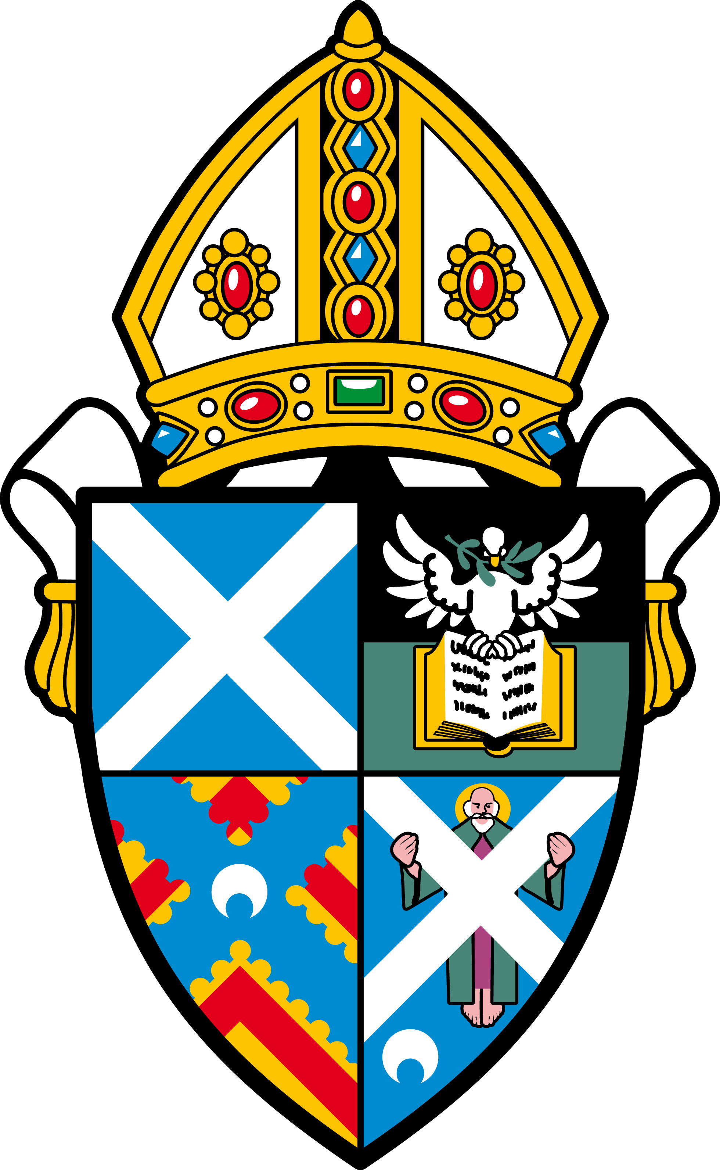

THE SCOTTISH EPISCOPAL CHURCH

The Diocese of St Andrews, Dunkeld and Dunblane is looking to
fill the following part-time position

St Mary’s, Birnam and Dunkeld with St Columbas, Stanley

Priest in Charge

St Mary’s Church is situated in Birnam on the River Tay at the gateway to the Highlands.

St Mary’s has a diverse and thriving congregation where there is a real sense of community and willingness to both support and enhance the spiritual lives of the local community.
The priest will also have charge of the small congregation at Stanley, a growing village five miles south.

We are seeking a part time priest in charge who is sensitive to the changing needs of the community, who is able to work collaboratively with community groups and other church denominations for the benefit of all.

The Vestry wishes to recruit someone who is keen to serve for two days a week, including Sunday worship, who wishes to help us grow while providing a source of pastoral care for our people.

For details, the application form and a copy of the congregational profile please contact Jane Anderson, Vestry Secretary (janeanderson180@btinternet.com). The closing date for applications is 9 February 2018 and interviews are to take place on 1 March 2018 at St Mary’s Church.

