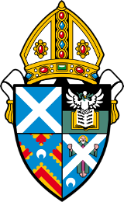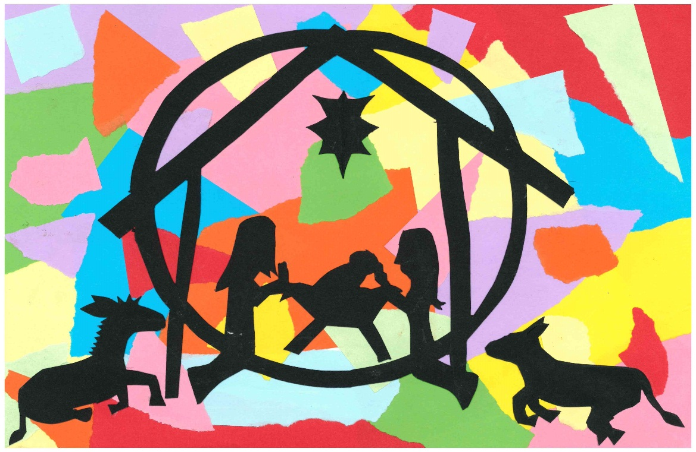

**Diocesan Christmas Card Competition**

Closing date **Monday** **13th November.** Cards will be sent out week commencing 24th November.   
Please make cheques payable to ‘Diocese of St Andrew’s, Dunkeld and Dunblane’ and send to Christmas Cards, Diocesan Office, 28A Balhousie Street, Perth, PH1 5HJ

Please send order form and payments to Diocesan Christmas Card Competition, 28A Balhousie St, Perth, PH1 5HJ. Cheques payable to ????  
 .

For more information Contact Carol Aitchison via the Diocesan office; bishopsec@standrews.anglican.org

SC**017654**

**Winning design by Laura Buxel, aged 10 from Young Church at St Mary’s, Dunblane**

Packs of 10 @ £4 a pack

£

Packs of 50 @ £18 a pack

£

Any funds made from the card sales will support Diocesan work with children and youth.